Changing 2D List Rows

Look at this code:
clubs = [["Art", 12], ["Chess", 18]]
new_club = ["Code", 15]
clubs.append(new_club)
clubs.insert(1, ["Music", 9])
del clubs[0]
for club in clubs:
print(club[0], club[1])

What do you think this code will display?
Click or tap here to enter text.

Run the code. Compare the result with your prediction:
Click or tap here to enter text.

Let’s investigate! Answer the questions below:
- Why must a new record be added as one complete inner list rather than as separate outer-list items?
Click or tap here to enter text.

- How do later row positions change after insert() adds a row at position 1?
Click or tap here to enter text.

- What happens to the position of a row after an earlier row is deleted?
Click or tap here to enter text.

- What three rows are printed after the append, insert and delete operations finish?
Click or tap here to enter text.

Changing 2D List Rows

Look at this code:
clubs = [["Art", 12], ["Chess", 18]]
new_club = ["Code", 15]
clubs.append(new_club)
clubs.insert(1, ["Music", 9])
del clubs[0]
for club in clubs:
print(club[0], club[1])

Use the code above to help you. After completing each challenge below, run your program to test that it works correctly. Save each completed challenge program in a new file.

Programming Challenges

Challenge 1
Insert ["Drama", 11] at row position 0 and remove the deletion line. The final output must begin Drama 11.
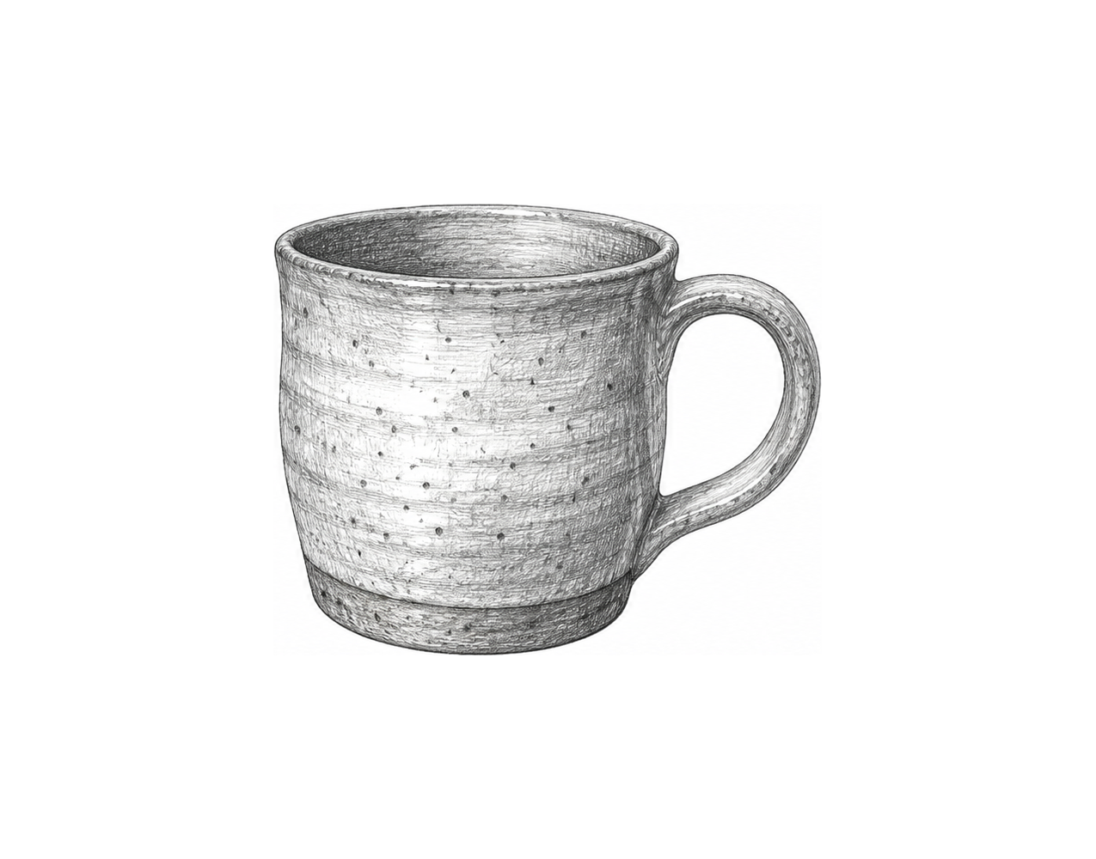

Challenge 2
Ask for a new club name and member count, build a two-field row, append it, then ask for one valid row position to delete. Display the remaining rows.

Challenge 3
Build an event schedule editor with three [event, room] rows. Insert one user-created row at a valid position, delete a different valid row from the enlarged schedule, and display numbered remaining rows using a counter.

Changing 2D List Rows

Fix the code!

This code has errors! Look closely at the code to find the problems:

clubs = [["Art", 12], ["Chess", 18]]
clubs.append("Code", 15)
del clubs[0][0]
print(clubs)

Rewrite the whole program in the box below with fixes to the errors.
Click or tap here to enter text.

After you are confident that you fixed all the errors, copy the code from the box and run it.

Did it work correctly on your first try? Did you find all the errors?
Click or tap here to enter text.

